Headteacher Weekly Newsletter

Week 14

Dear Parents/Carers

Road Safety

When dropping off/collecting your child on the roads surrounding the school, please can you make sure that you do not park in the bus stop, in front of the school gates, on double yellow lines or across residents' driveways. We would like to maintain our good relationship with our neighbours.

We are still receiving reports of a small number of pupils displaying poor road awareness on their way home from school. The roads around school are incredibly busy at both the start and end of the school day. As a matter of urgency and safety to both the student and other road users, please take extra care when travelling to and from school. YOUR SAFETY IS PARAMOUNT!

Christmas Jumper Day

Friday 20th December is a non school uniform day to raise money for ‘Save the Children.’ All pupils are required to bring in a £1 and it would be good to see as many as possible in Christmas Jumpers.

Home /School Communication

May we request that parents adhere to our communication policy and respect the work/life balance of teachers. The policy can be found on our website pages under ‘Parents’ but essentially parents should not be sending emails or expect a reply to an email sent after 4pm.

In addition, please note that should you need to see a member of a staff, an appointment would be necessary. Unfortunately, we are unable to assist with walk-ins. Your co-operation in this is much appreciated.

Used Stamps Appeal

Toynbee school in Chandlers Ford has the only purpose built secondary resource that is fully equipped to support the needs of pupils with a vison impairment in Hampshire. The pupils are fully integrated into mainstream school and enjoy all aspects of the curriculum with support from specialist Learning Support Assistants, including PE,
Technology and Science.

The Toynbee VI Resource Centre are collecting used stamps - British or foreign - for Hampshire Association
For The Care Of The Blind in Eastleigh, to help them raise funds to support many people with sight impairment
in the local community.

Please place any used stamps you have in the jar on the reception desk or in the box in the VI Resource Centre.

Many thanks for your support.

Helpful Hounds

Just to make you aware, Helpful hounds is now one of the “Good Causes” supported by the BH Coastal Lottery.
The tickets are £1 per week and 50% come back to Helpful Hounds. Plus, participants have the chance to
Win a top prize of £25,000. We would be delighted if you would support this, yourself but, even more
importantly can you promote this to friends, family and people at work.

https://www.bhcoastallottery.co.uk
Peter Rufus
Trustee and CEO (Volunteer)
Helpful Hounds Assistance Dogs
admin@helpfulhounds.org.uk

Registered Charity in England: No.1181017
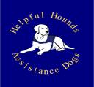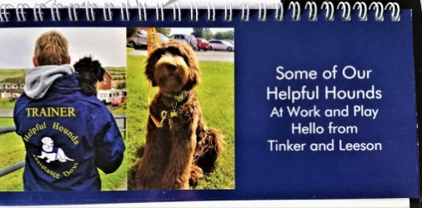

Last Chance for (Free Delivery Code) from Skoolkit

I just wanted to let you know we are offering a free delivery promotion on all online orders placed during Wednesday 11th December – Friday 13th December which parents can take advantage of if they don’t fancy
tackling the parking and chaos of the town centres.

Free delivery code XMAS19 to use from Wednesday 11th December – Friday 13th December.

The code is only valid during the time specified and will need to be entered when parents are viewing their
baskets online.

Even though our Warehouse will be closed over the Christmas and New Year period our shops will still be open, please
check our website for individual shops opening times, as we are giving our shop staff an extra day off so they can enjoy
the festivities.

Last Day of Term Arrangements

School will close early for the Christmas holidays at 12:00 noon on 20 December 2019.

Dates for your Diary:

20 December – ‘Christmas Jumper Day’ £1

20 December - Early Finish – 12 noon

6 January – Late start – 11:15 (All pupils to tutor groups)
Have a nice weekend.

Regards

Mr Matthew Longden
Headteacher

